

C programming File

Section :- AU(2) Roll no. : 59

Submitted by : SIDDHANT JAIN

Submitted to : Ms. Gurpreet Mam

Submitted on : 3rd Dec. 2023

**Q.1 WAP to Convert a given number into decimal,octal,Hexadecimal,HEXADECIMAL respectively.**

Ans. #include<stdio.h>

int main()

{

int n;printf("Please enter a number");

scanf("%d",&n);

printf("The Value of %d in octal is %o\n",n,n);

printf("The Value of %d in hexadecimal is %x\n",n,n);

printf("The Value of %d in HEXADECIMAL is %X\n",n,n);

printf("The Value of %d in exponential is %e\n",n,n);

printf("The Value of %d in EXPONENTIAL is %E\n",n,n);

}

**OUPUT** :-

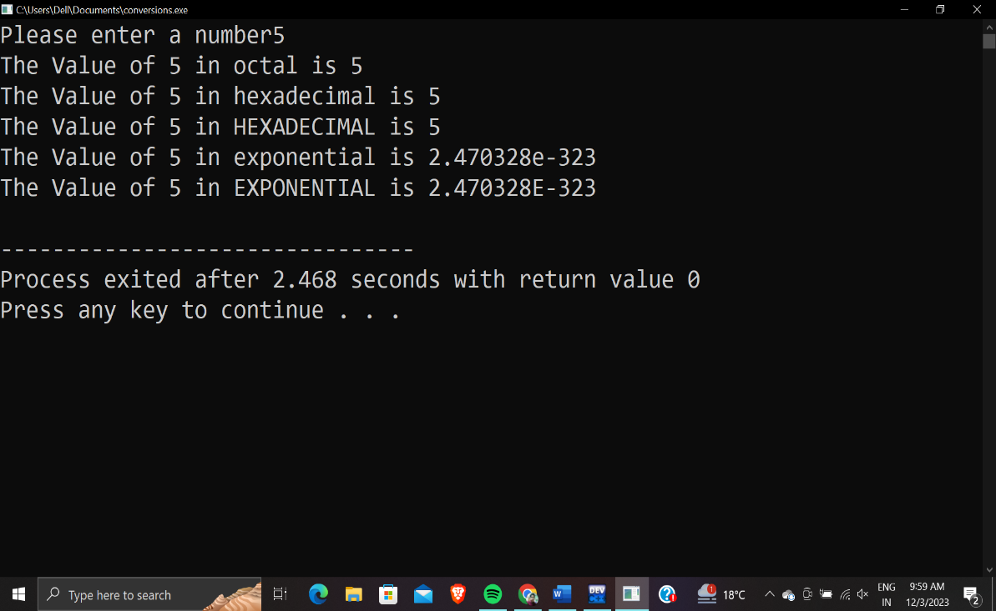

**Q.2 WAP for doing currency denomination.**

Ans. #include<stdio.h>

int main(){

int amount;

int n2000, n500, n200, n100, n50, n20, n10, n5, n2, n1;

printf("enter the amount : ");

scanf("%d",&amount);

n2000=amount/2000;

amount=amount%2000;

n500=amount/500;

amount=amount%500;

n200=amount/200;

amount=amount%200;

n100=amount/100;

amount=amount%100;

n50=amount/50;

amount=amount%50;

n20=amount/20;

amount=amount%20;

n10=amount/10;

amount=amount%10;

n5=amount/5;

amount=amount%5;

n2=amount/2;

amount=amount%2;

n1=amount/1;

amount=amount%1;

printf(" Rs 2000= %d\nRs 500= %d\nRs 200= %d\nRs 100= %d\nRs 50= %d\nRs 20= %d\nRs 10= %d\nRs 5= %d\nRs 2= %d\nRs 1= %d",n2000,n500,n200,n100,n50,n20,n10,n5,n2,n1);

return 0;

}

OUTPUT :-

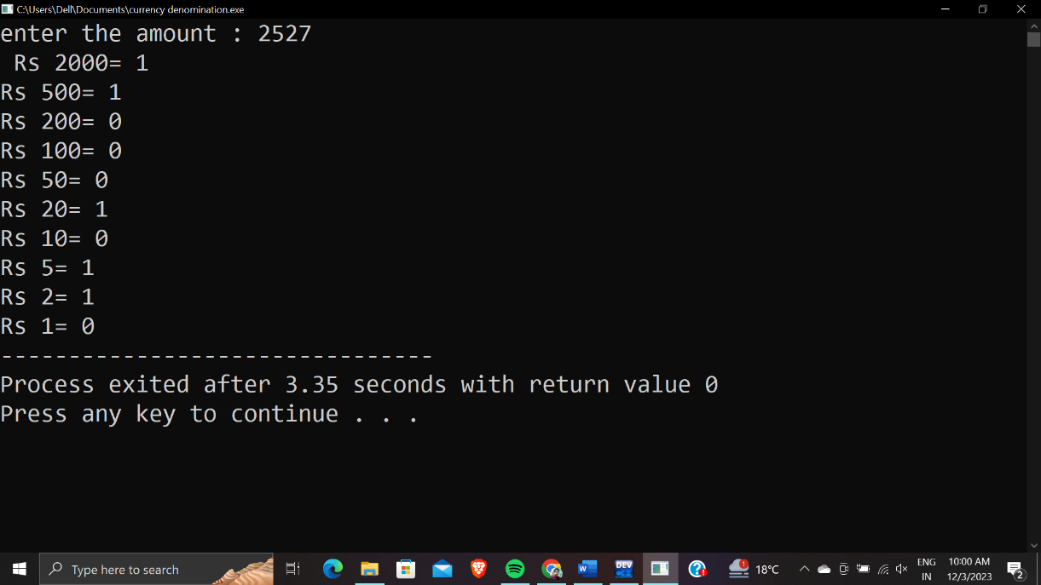

**Q.3 WAP to implement the concept of different types of variables.(Extern,Auto,Global,Local,Static).**

Ans. #include<stdio.h>

int p=50;//global variables(p=50)

void f()

{

int p=10;//local varibles(p=10)

printf("function inside %d\n",p);

}

void m()

{

int a=10;

static int b=20;//static variable

a++;

b++;

printf("a=%d,b=%d\n",a,b);

}

int main()

{

int p=20;//auto variable(p=20)by default auto in main function

f();

printf("in main function:- %d\n",p);

int a=50,b= 60;

m();

printf("a=%d and b=%d\n",a,b);

m();

m();

extern int c;//extern variable

printf("%d",c);

}

int c=90;

OUTPUT :-

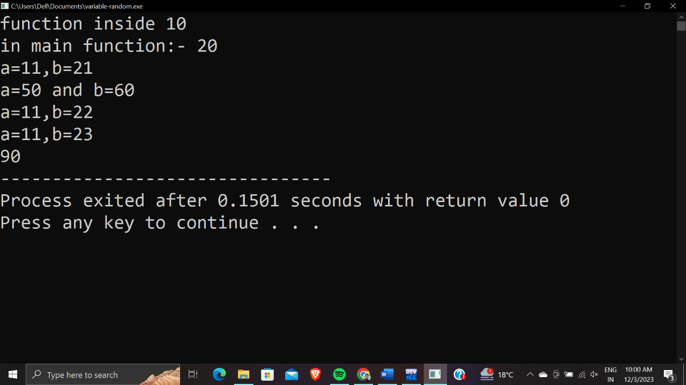

**Q.4** **WAP to implement a program for librarian so that he/she can issue books and take back fine for not returning book on time.**

Ans. #include<stdio.h>

int main(){

int d,e,a;

char t;

printf("enter the type of book ('A' or 'B'): ");

scanf("%c",&t);

printf("enter the number of days : ");

scanf("%d",&d);

if(t=='A')

{

if(d<=7)

{

printf("no late fee");

}

else if(d>=8 || d<=10)

{

e=d-7;

a=e*2;

printf("%d",a);

}

else

{

e=d-7;

a=e*5;

printf("%d",a);

}

}

if(t=='B')

{

if(d<=5)

{

printf("no late fee");

}

else if(d>=6 || d<=10)

{

e=d-7;

a=e*5;

printf("%d",a);

}

else

{

e=d-7;

a=e*10;

printf("%d",a);

}

}

return 0;

}

OUTPUT :-

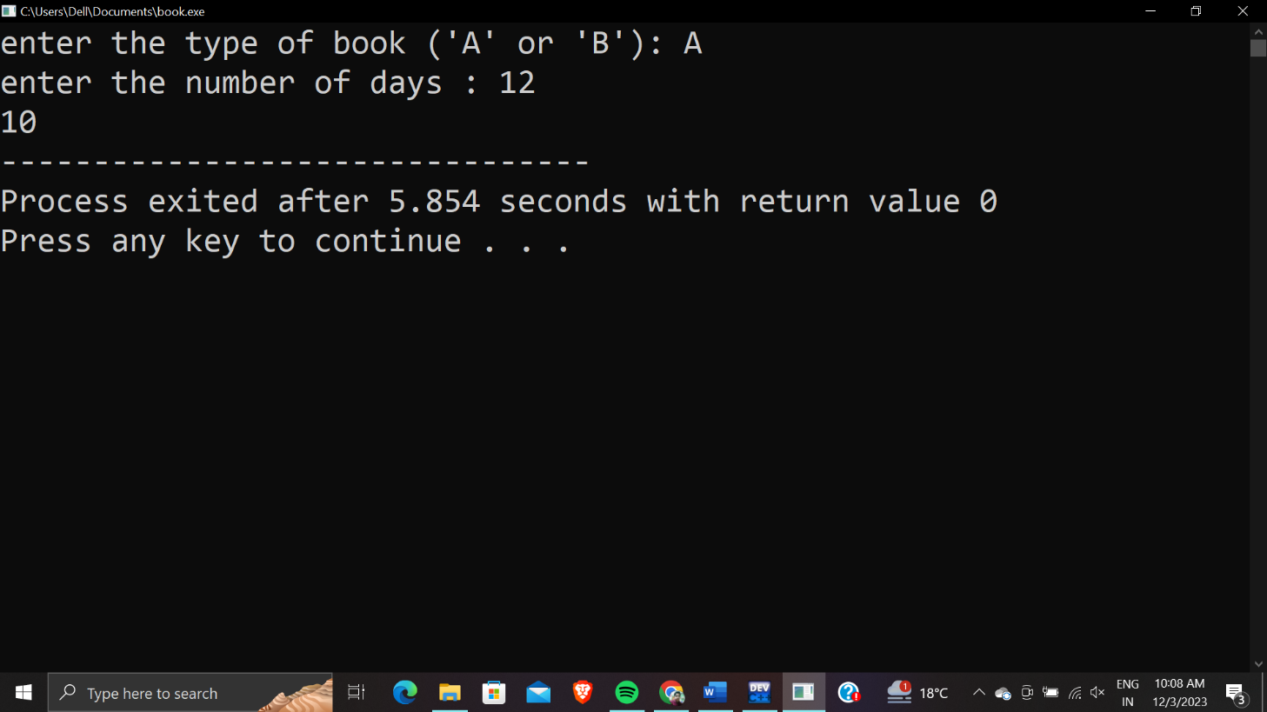

**Q.5 WAP to find & print the roots of a quadratic equation.**

**Ans.**  #include<stdio.h>

#include<math.h>

int main(){

float a,b,c,d,x;

printf("enter the value a,b and c : ");

scanf("%f%f%f",&a,&b,&c);

d=pow((pow(b,2)-(4*a*c)),(1/2));

if(d>0)

{

x=(-b+d)/(2*a);

printf("%d",x);

}

else

{

x=(-b-d)/(2*a);

printf("%d",x);

}

return 0;

}

OUTput :-

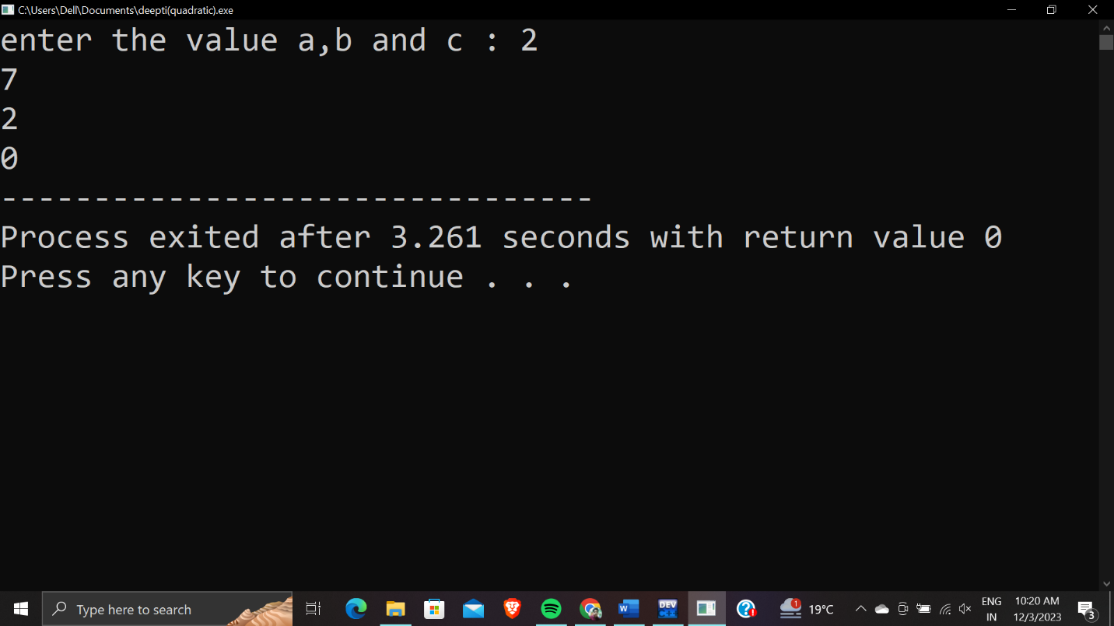

**Q.6 WAP to print an Arithematic progression,and find and print the sum of all the terms.**

**Ans.**  #include<stdio.h>

int main(){

int a, n, d, m, sum=0;

printf("Input the starting number of the A.P. series : ");

scanf("%d",&a);

printf("Input the number of terms for the A.P. series : ");

scanf("%d",&n);

printf("Input the common difference of A.P. series : ");

scanf("%d",&d);

printf("%d",a);

for(int i=1; i<=n; i++)

{

m=a+i*d;

printf(" + %d",m);

sum=sum+m;

}

printf(" = %d",sum);

return 0;

}

OUtPUT :-

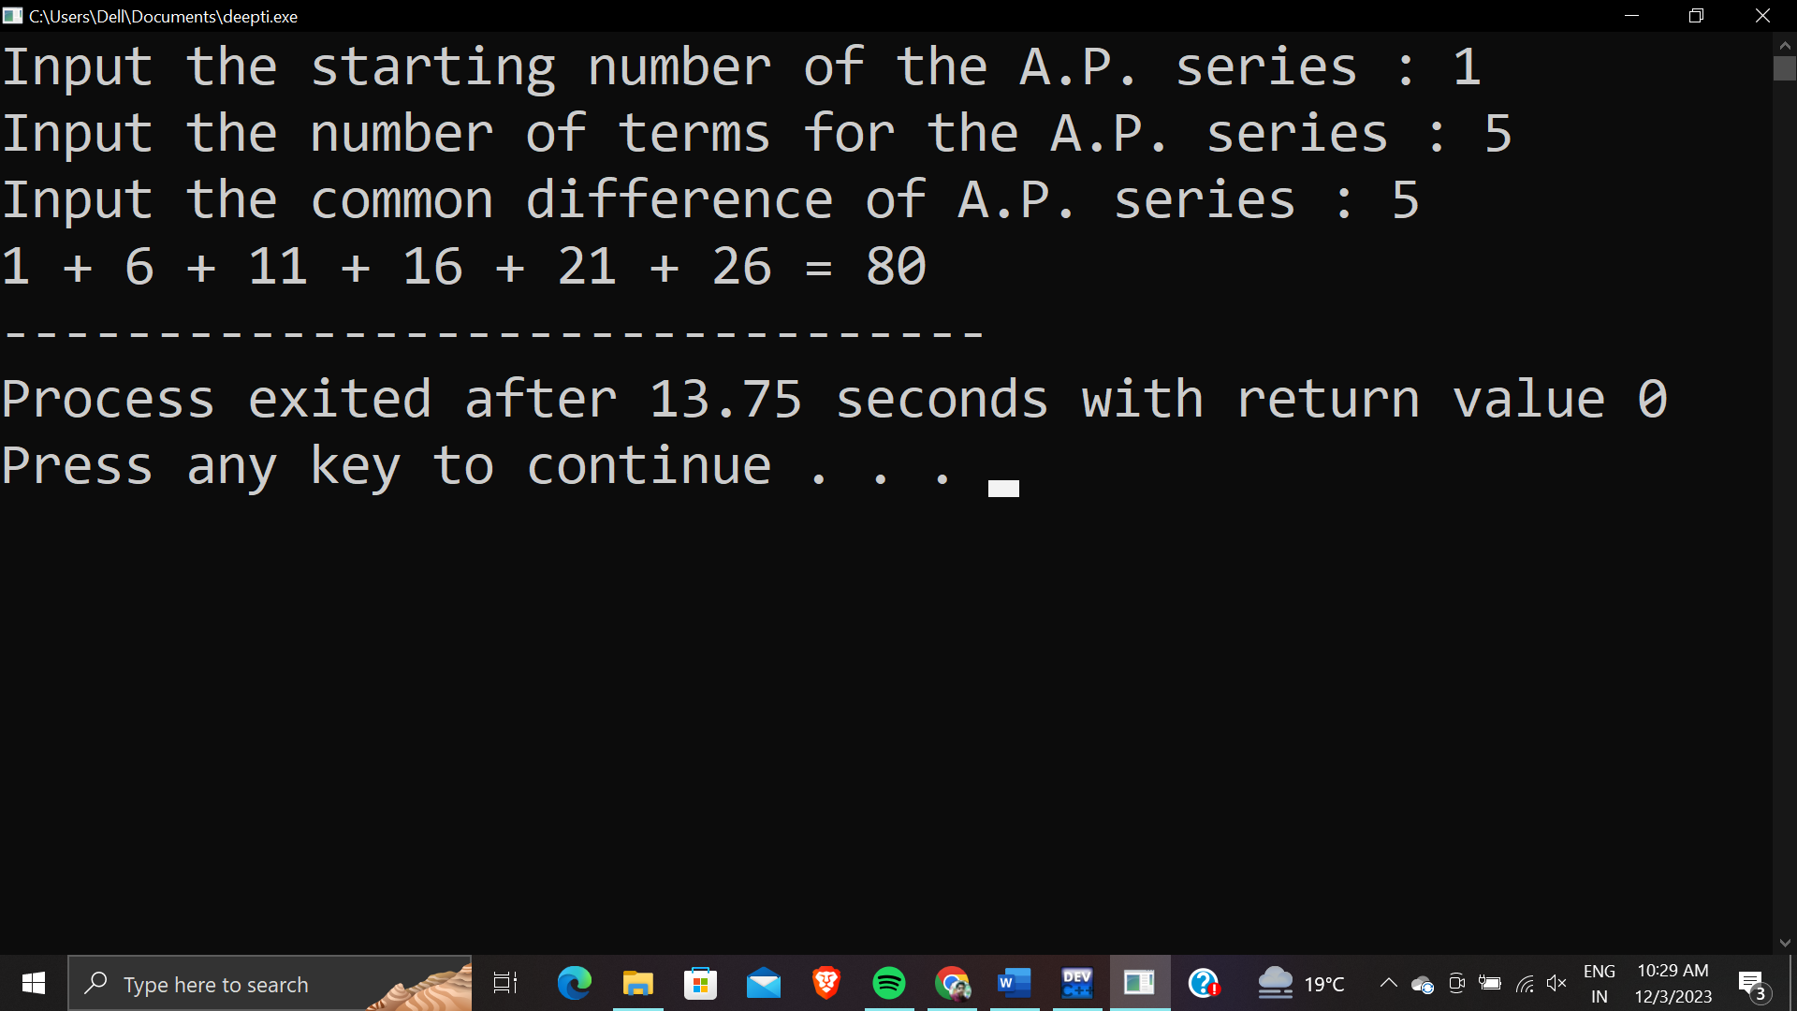

**Q.6 WAP to print a diamond using patterns.**

**Ans.**

#include<stdio.h>

int main()

{

int ch,i,j;

printf("Enter the size");

scanf("%d",&ch);

for(i=i;i<=ch;i++)

{

for(int k=i;k<ch;k++)

{

printf(" ");

}

for(j=1;j<=i;j++)

{

printf("* ");

}

printf("\n");

}

for(i=ch;i>=1;i--)

{

for(int k=(ch-1);k>=i;k--)

{

printf(" ");

}

for(j=i;j>=1;j--)

{

printf("* ");

}

printf("\n");

}

return 0;

}

OUTPUT:-

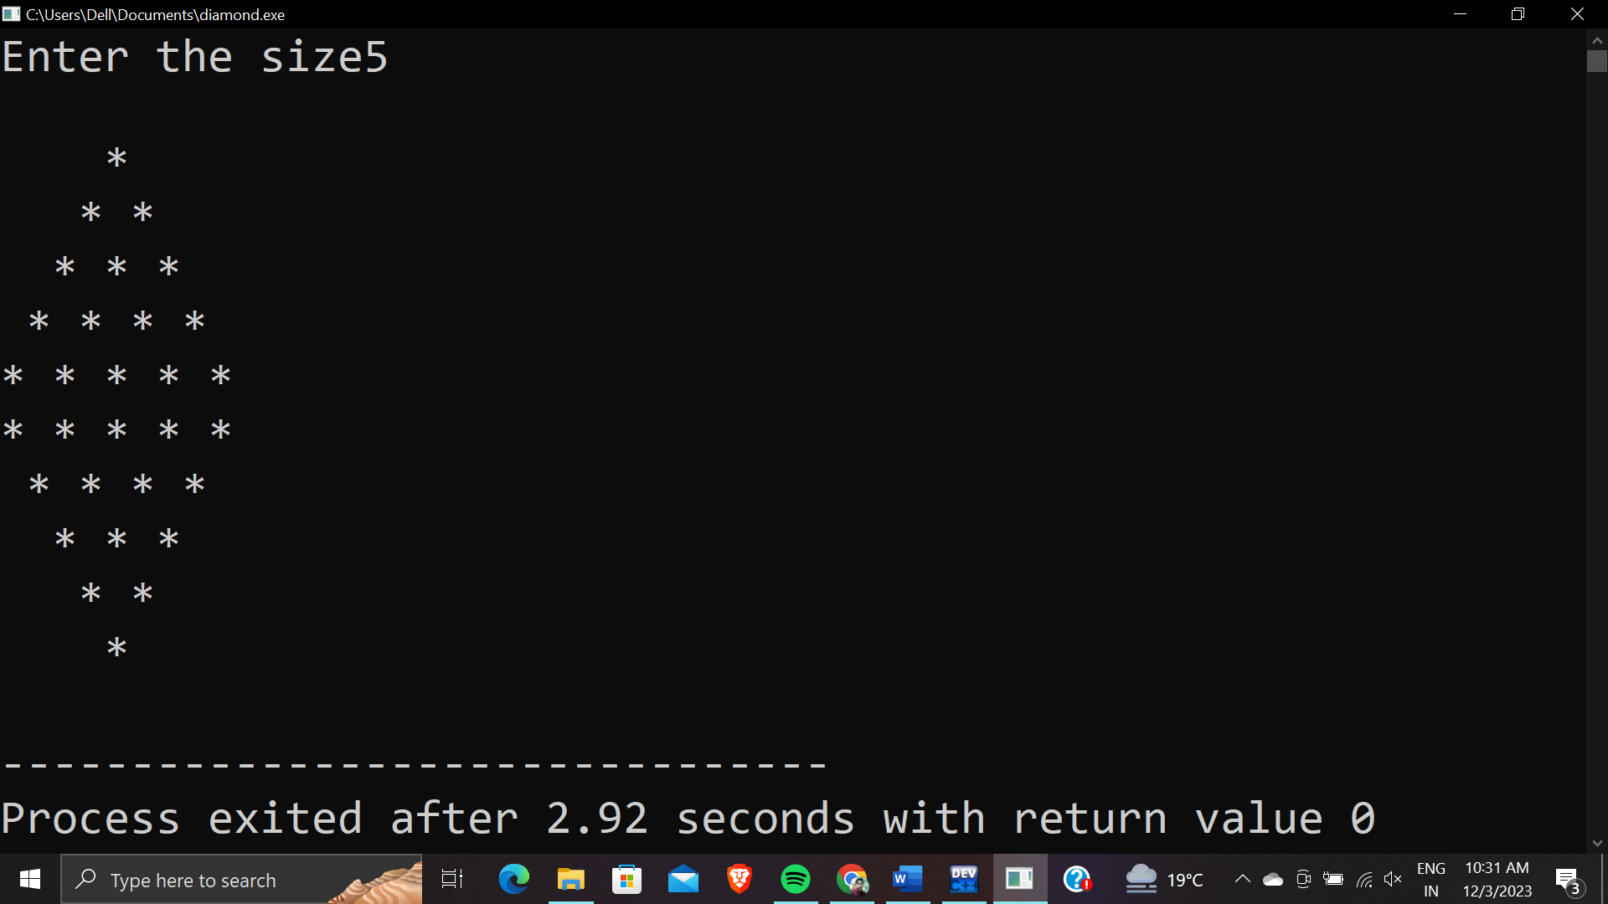

**Q.7 WAP To make a digital clock.**

**Ans.**  #include<stdio.h>

#include<windows.h>

int main()

{

for(int h=0;h<24;h++){

for(int m=0;m<60;m++)

{

for(int s=0;s<60;s++)

{

system("cls");

printf("[%02d : %02d : %02d]",h,m,s);

Sleep(1000);

}

}

}

return 0;

}

OUTPUT :-

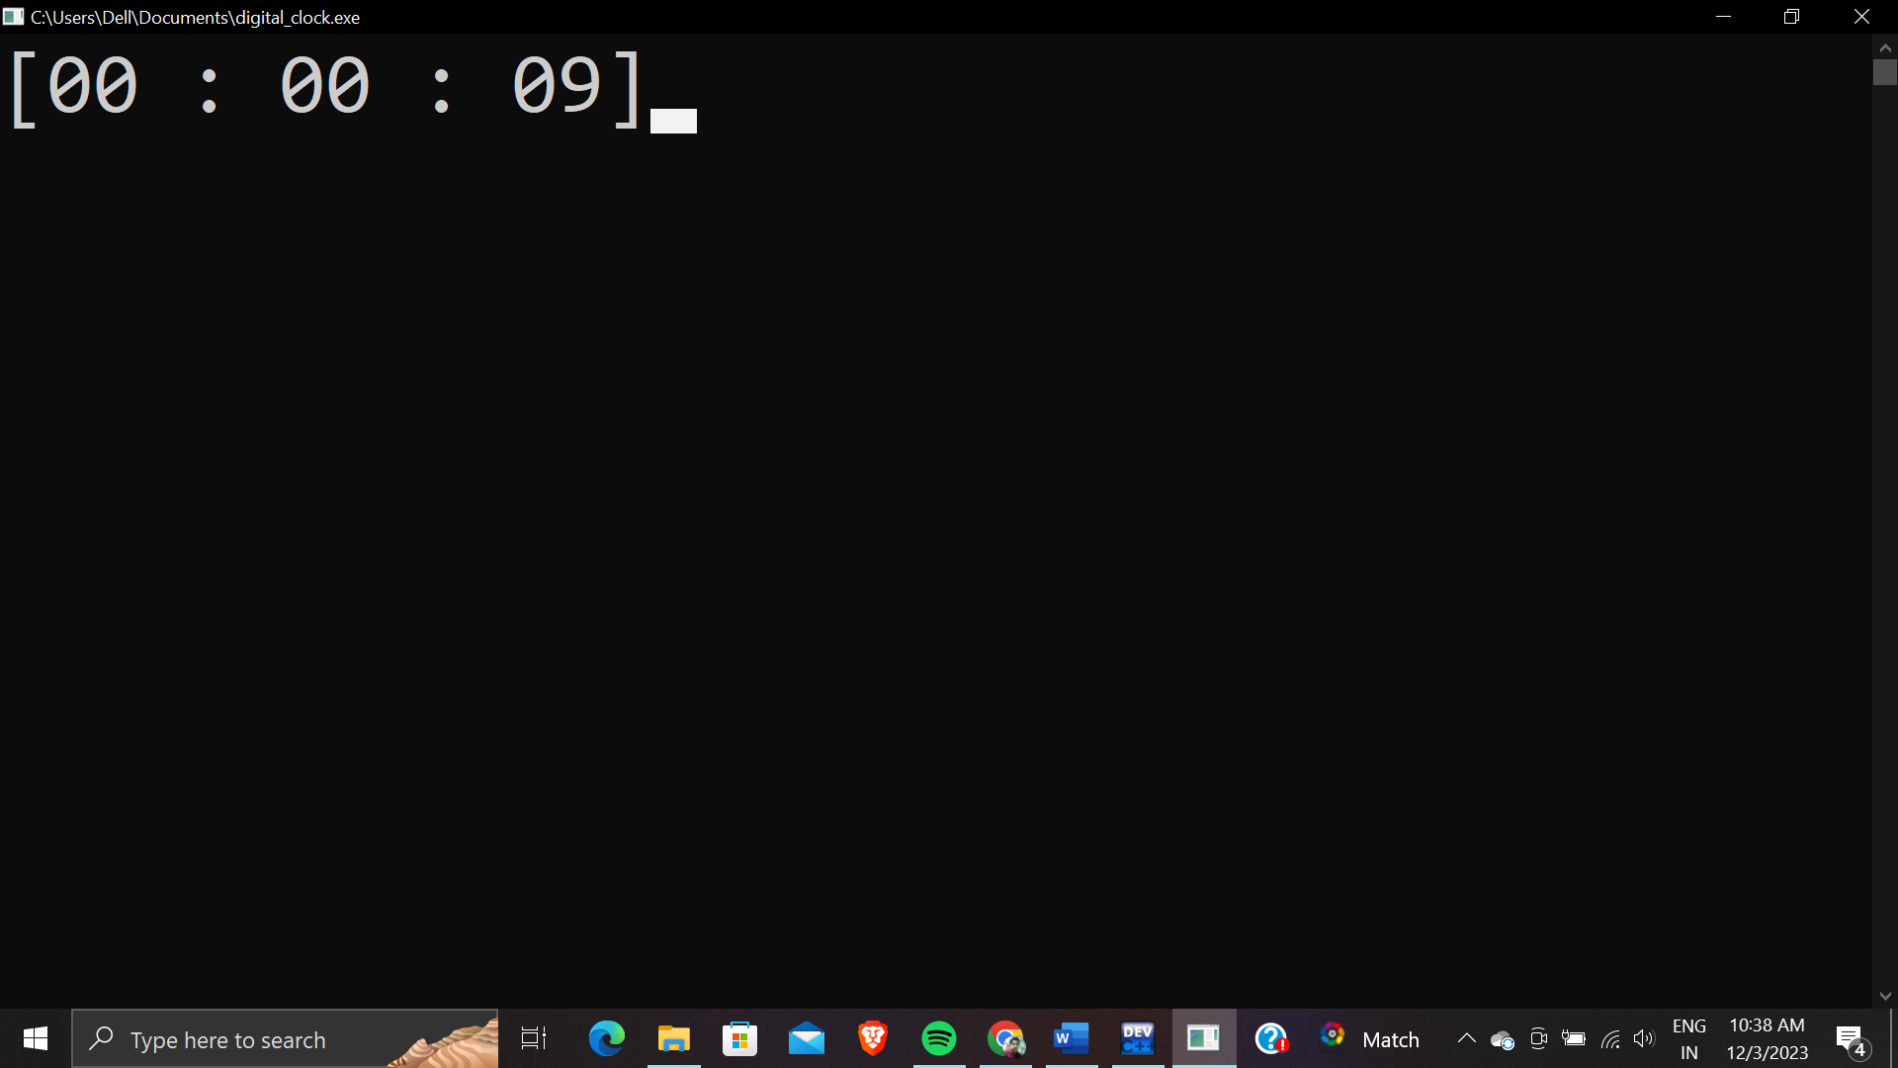

**Q.8 WAP to print characters in reverse (shaped like a pyramid.)**

**Ans.**  #include<stdio.h>

int main()

{

char ch,c='Z',i,j;

printf("Enter the range of printing characters in terms of Characters in reverse shaped like a pyramid");

scanf("%c",&ch);

for(i='A';i<=ch;i++)

{

for(int k=i;k<ch;k++)

{

printf(" ");

}

for(j='A';j<=i;j++)

{

printf("%c ",c);

c--;

}

printf("\n");

}

return 0;

}

Output :-

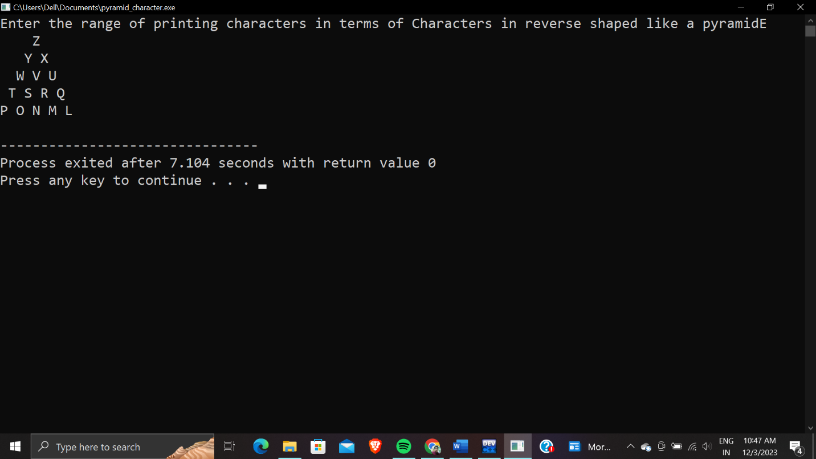

**Q.9 WAP to print counting of numbers in forward and backward as per user’s choice. Taking all the inputs from the user.**

**Ans.**  #include<stdio.h>

#include<conio.h>

int main()

{

char choice;

char choice2;

int st,en,jump;

printf("HEY USER !! Please enter the starting point of your counting");

scanf("%d",&st);

printf(" Please enter the ending point of your counting");

scanf("%d",&en);

printf( "Please enter the jump you want your counting to make");

scanf("%d",&jump);

printf("please enter f if you want to print forward and b if want to print backward");

scanf("%c ",&choice);

printf("please enter h if you want to print horizontally and v if want to print vertically");

scanf("%c ",&choice2);

if(choice=='f')

{

if(choice2=='h')

{

for(int i=st;i<=en;i=i+jump)

{

printf("%d \t",i);

}

}

else if(choice2=='v')

{

for(int i=st;i<=en;i=i+jump)

{

printf("%d \n",i);

}

}

else{

printf("WRONG INPUT");

}

}

else if(choice=='b')

{

if(choice2=='h')

{

for(int i=en;i<=st;i=i-jump)

{

printf("%d \t",i);

}

}

else if(choice2=='v')

{

for(int i=en;i<=st;i=i-jump)

{

printf("%d \n",i);

}

}

else{

printf("WRONG INPUT");

}

}

else

{

printf("Invalid input");

}

return 0;

}

OUTPUT :-

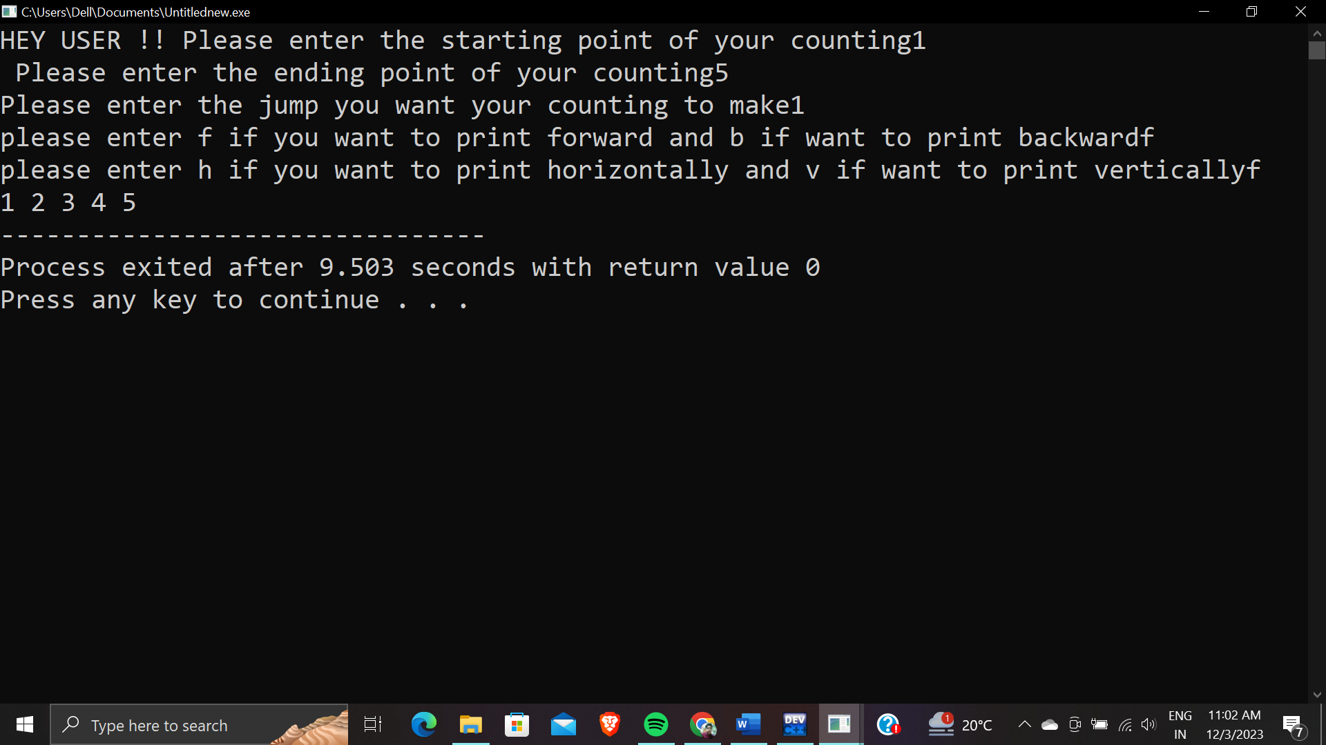

**Q.10 WAP to find and print the average and percentage of the numbers given to you by the user.**

**Ans.**  #include<stdio.h>

#include<conio.h>

int main()

{

int a,b,c,d,e; float avg,per;

scanf("%d%d%d%d%d",&a,&b,&c,&d,&e);

{

avg=(a+b+c+d+e)/5;

per=(avg*100)/500;

printf("your average is %.2f",avg);

printf("your percenage is %.2f %%",per);

return 0;

}

Output :-

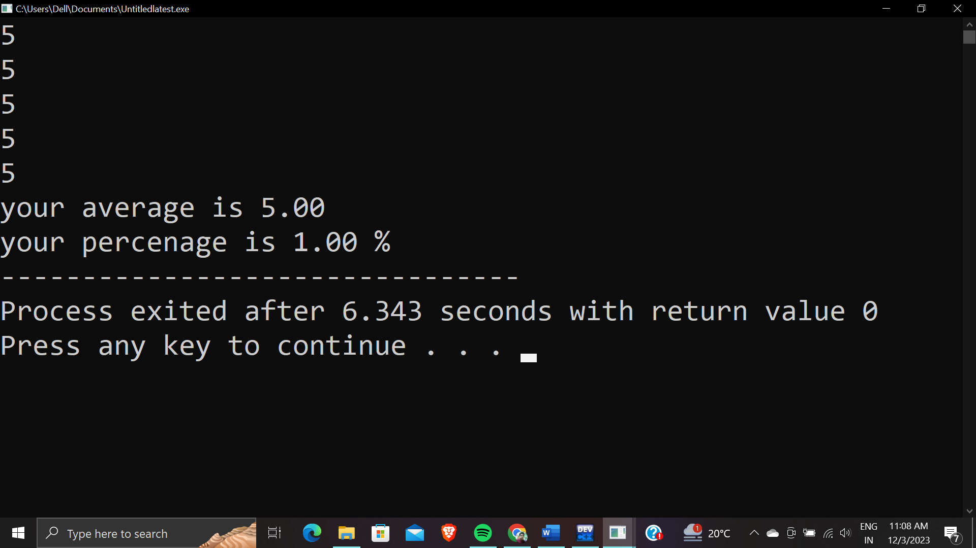

**Q.11 WAP To print the lowest marks among the marks given to you by the user.**

**Ans.**  #include<stdio.h>

#include<conio.h>

int main()

{

int m1,m2,m3;

printf("please enter your marks of 3 subjects");

scanf("%d%d%d",&m1,&m2,&m3);

int d=(m1<m2)? (m1<m3? m1:m3):(m2<m3?m2:m3);

printf("oops !! yourlowest marks are %d..better luck next time",d);

printf(":(");

}

**Output :-**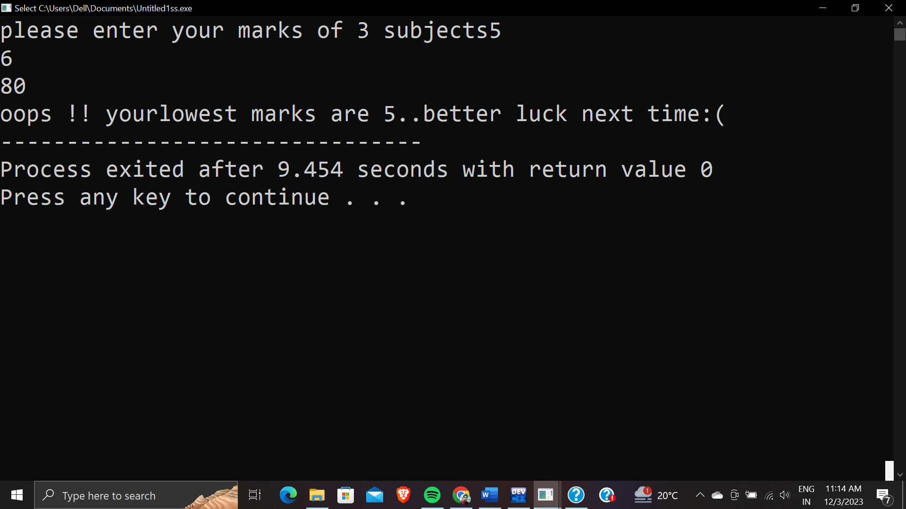

**Q.12 WAP to print the transpose of a given matrix.**

**Ans.**  #include<stdio.h>

int main()

{

int m,n;

printf("Enter the rows and columns of Matrix");

scanf("%d%d",&m,&n);

int a[m][n];

int b[m][n];

printf("Enter the elements of matrix");

for(int i=0;i<m;i++)

{

for(int j=0;j<n;j++)

{

scanf("%d",&a[i][j]);

}

}

printf("Normal Matrix: \n");

for(int i=0;i<m;i++)

{

for(int j=0;j<n;j++)

{

printf("%d ",a[i][j]);

}

printf("\n");

}

for(int i=0;i<m;i++)

{

for(int j=0;j<n;j++)

{

b[i][j]=a[j][i];

}

}

printf("Transpose Matrix :\n");

for(int i=0;i<m;i++)

{

for(int j=0;j<n;j++)

{

printf("%d ",b[i][j]);

}

printf("\n");

}

return 0;

}

Output :

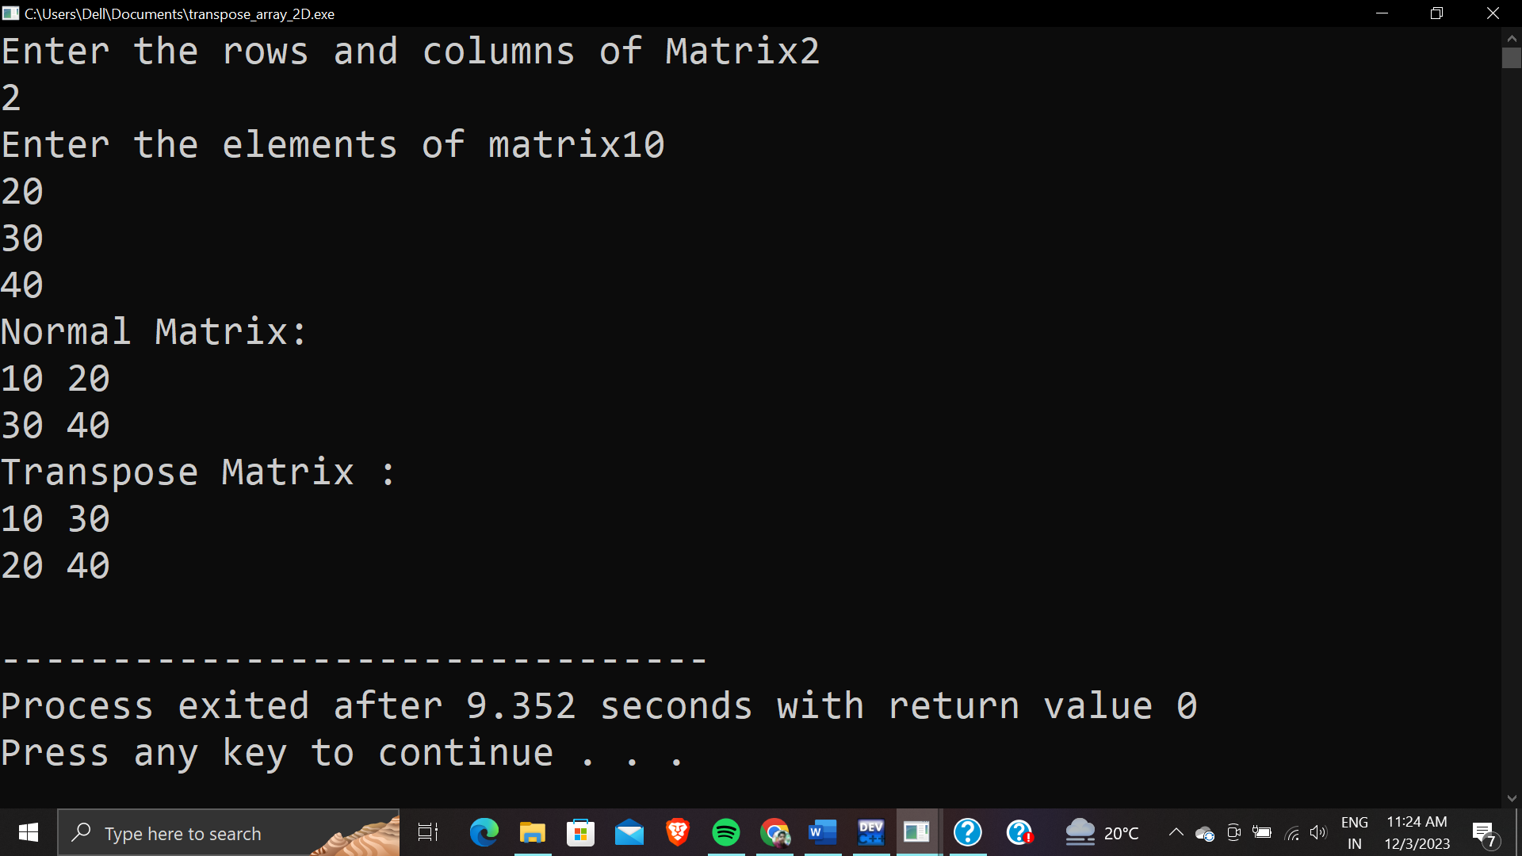

**Q.13 WAP to print the multiplaction table of a number.**

**Ans.**  #include<stdio.h>

int main()

{int n;

scanf("%d",&n);

for(int i=1;i<=10;i++)

{printf("%d * %d =%d\n",n,i,n*i);

}

return 0;

}

Output :-

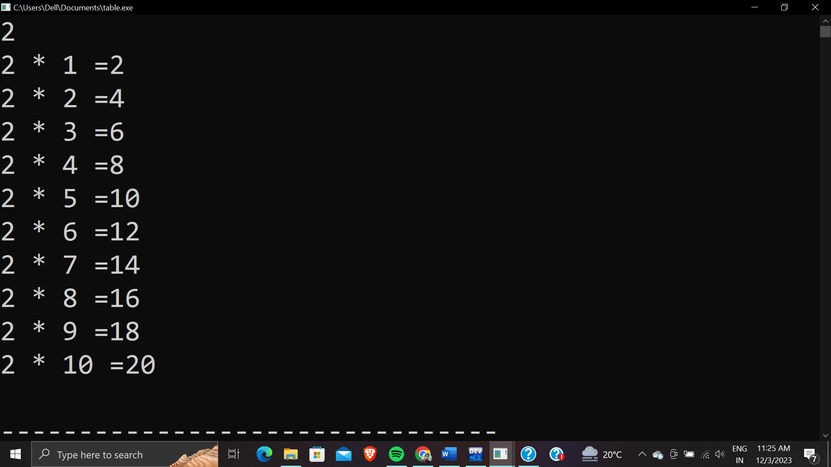

**Q.14 WAP to swap 2 numbers using bitwise operator.**

**Ans.**  #include<stdio.h>

int main()

{int a,b;

printf("enter two no.");

scanf("%d%d",&a,&b);

printf("vaue of a,b before swapping %d %d",a,b);

a=a^b;

b=a^b;

a=a^b;

printf("\n%d\n%d",a,b);

return 0;

}

Output :-

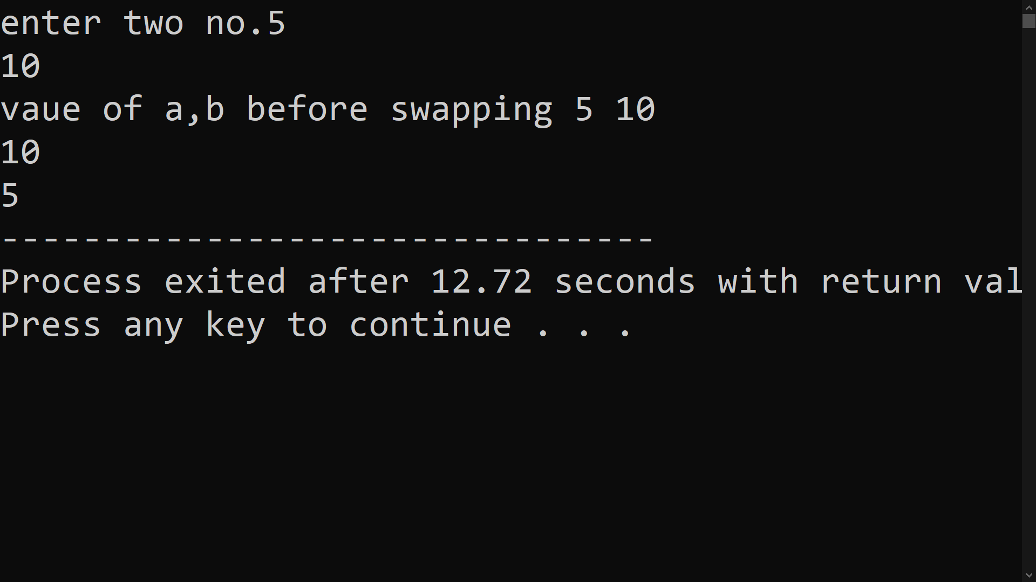

**Q.15 WAP To summing up elements in a 2D array.**

**Ans.**  #include<stdio.h>

int main()

{

int m,n;

printf("Enter the rows and columns of 2-D array");

scanf("%d%d",&m,&n);

int a[m][n];

int b[m][n];

int sum[m][n];

printf("Enter the elements of matrixes1");

for(int i=0;i<m;i++)

{

for(int j=0;j<n;j++)

{

scanf("%d",&a[i][j]);

}

}

printf("Enter the elements of matrixes2");

for(int i=0;i<m;i++)

{

for(int j=0;j<n;j++)

{

scanf("%d",&b[i][j]);

}

}

for(int i=0;i<m;i++)

{

for(int j=0;j<n;j++)

{

sum[i][j]=a[i][j]+b[i][j];

}

}

printf("Sum of both the matrixes is :- \n");

for(int i=0;i<m;i++)

{

for(int j=0;j<n;j++)

{

printf("%d ",sum[i][j]);

}

printf("\n");

}

return 0;

}

Output:-

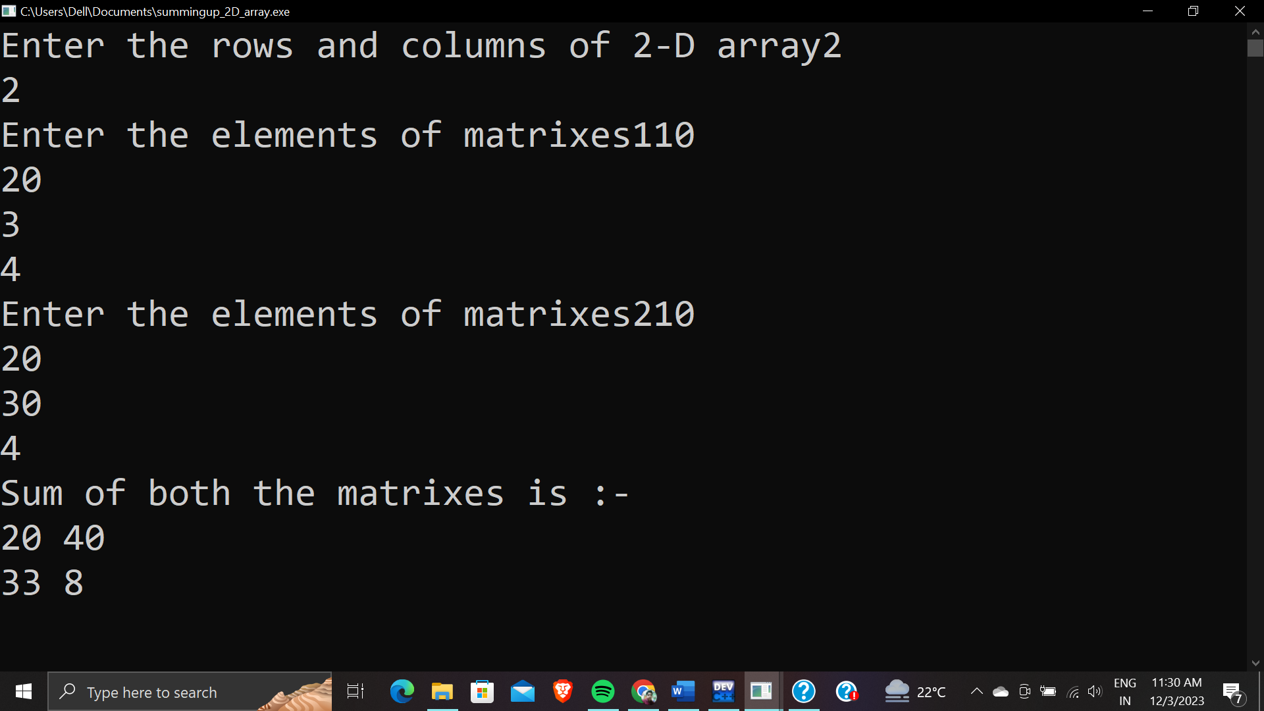

**Q.16 WAP to do the sum of two 2D arrays.**

**Ans.**  #include<stdio.h>

int main()

{

int m,n;

printf("Enter the rows and columns of 2-D array");

scanf("%d%d",&m,&n);

int a[m][n];

printf("Enter the elements of matrixes");

for(int i=0;i<m;i++)

{

for(int j=0;j<n;j++)

{

scanf("%d",&a[i][j]);

}

}

int sum=0;

for(int i=0;i<m;i++)

{

for(int j=0;j<n;j++)

{

printf("%d ",a[i][j]);

sum=sum+a[i][j];

}

printf("\n");

}

printf("The sum is %d",sum);

return 0;

}

Output:-

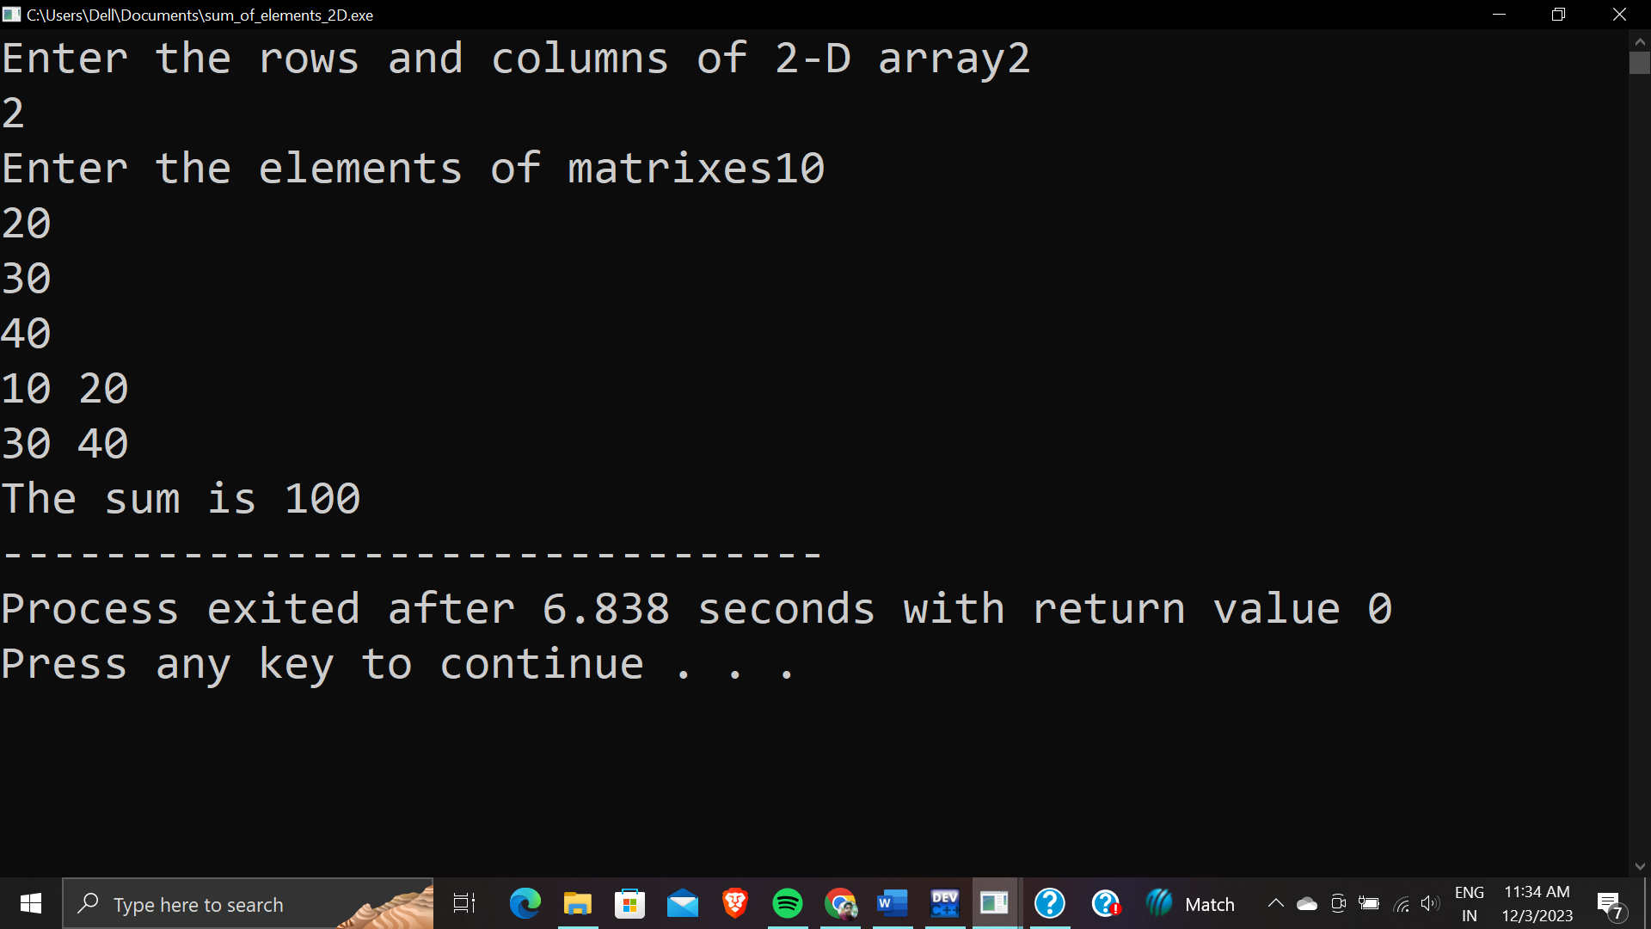

**Q.17 WAP to do sum of diagonals,upper triangle,lower triangle of 2 arrays.**

**Ans.**  #include<stdio.h>

int main()

{

int m,n;

printf("Enter the rows and columns of Matrix");

scanf("%d%d",&m,&n);

int a[m][n];

printf("Enter the elements of matrix");

for(int i=0;i<m;i++)

{

for(int j=0;j<n;j++)

{

scanf("%d",&a[i][j]);

}

}

printf("Normal Matrix\n");

for(int i=0;i<m;i++)

{

for(int j=0;j<n;j++)

{

printf("%3d ",a[i][j]);

}

printf("\n");

}

int sum=0,sumup=0,sumlow=0;

for(int i=0;i<m;i++)

{

for(int j=0;j<n;j++)

{

if(i==j)

{

sum=sum+a[i][j];

}

if(j>i)

{

sumup=sumup+a[i][j];

}

if(i>j)

{

sumlow=sumlow+a[i][j];

}

}

}

printf("Sum of Diagnols is : %d\n",sum);

printf("Sum of upper triangle is : %d\n",sumup);

printf("Sum of lower triangle is : %d",sumlow);

return 0;

}

Output :-

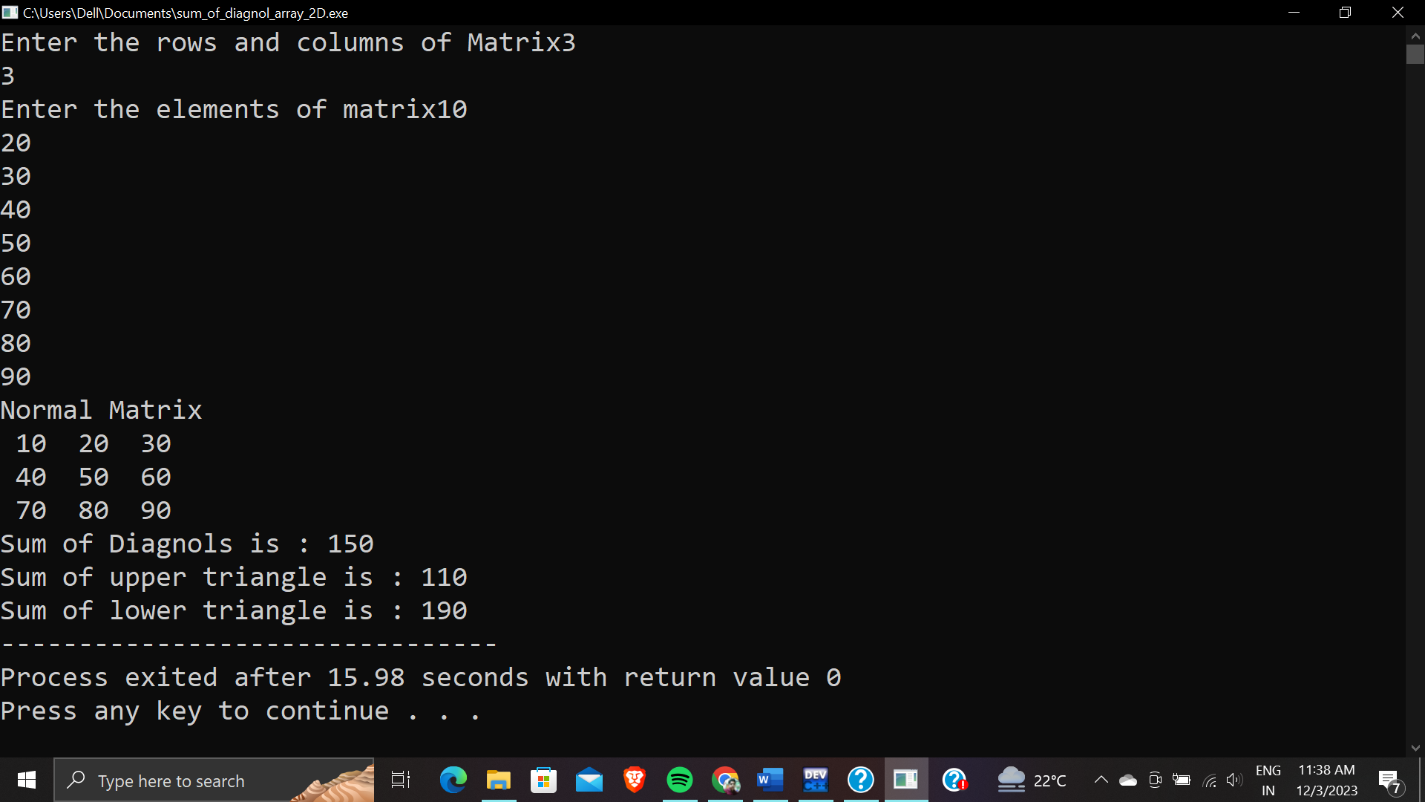

**Q. 18 WAP to check whether the number is strong number or not.**

**Ans.**  #include <stdio.h>

int fact(int r)

{

int mul=1;

for(int i=1;i<=r;i++)

{

mul=mul*i;

}

return mul;

}

int main()

{

int n;

int sum=0;

printf("Enter a number");

scanf("%d",&n);

int k=n;

int r;

while(k!=0)

{

r=k%10;

int f=fact(r);

k=k/10;

sum=sum+f;

}

if(sum==n)

{

printf("\nNumber is a strong");

}

else

{

printf("\nNumber is not a strong");

}

return 0;

}

Output:-

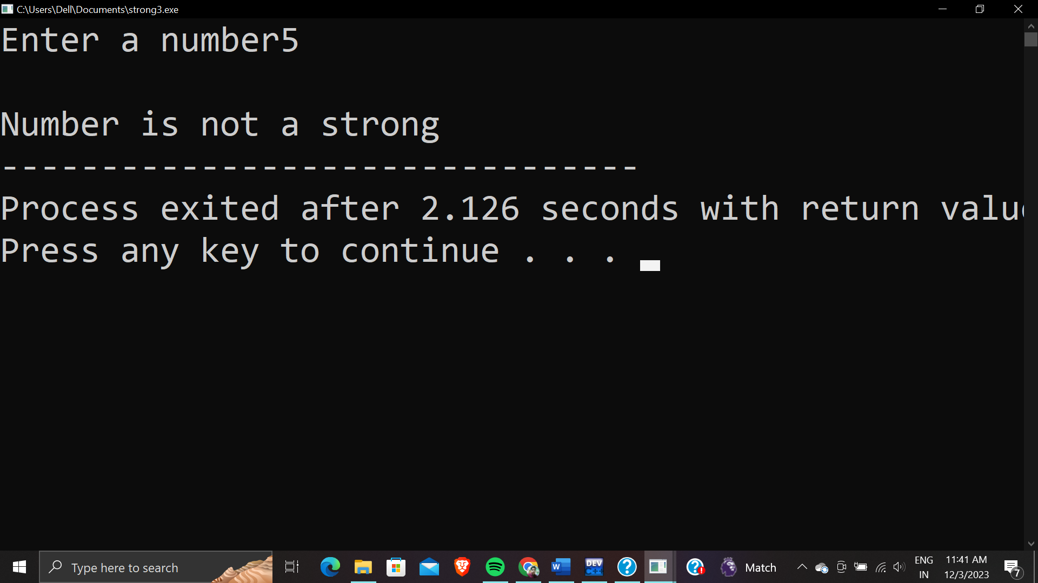

**Q.19 WAP To print the length of string using inbuilt function.**

**Ans.**  #include<stdio.h>

#include<string.h>

int main()

{

char name[50];

puts("Please enter the String");

gets(name);

printf("%d",strlen(name));

}

Output:-

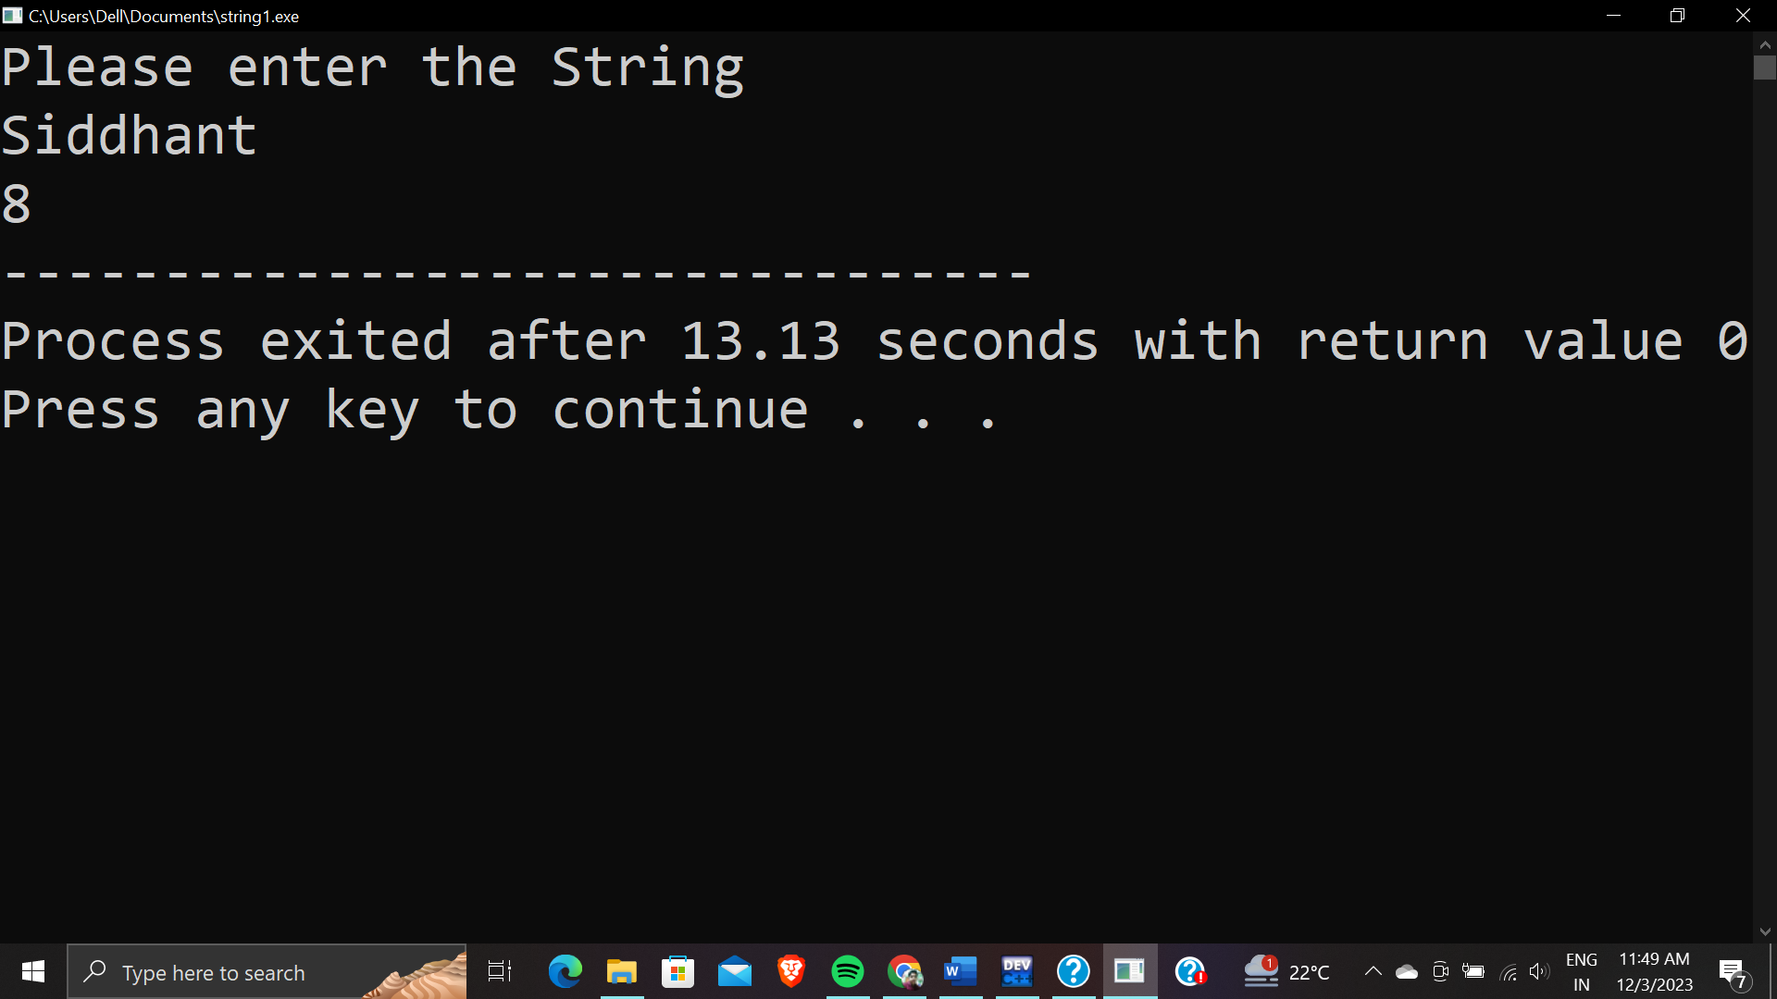

**Q.20 WAP to check that given matrix is sparse matrix or not.**

**Ans.**  #include<stdio.h>

int main()

{

int m,n;

printf("Enter the rows and columns of Matrix");

scanf("%d%d",&m,&n);

int a[m][n];

printf("Enter the elements of matrix");

for(int i=0;i<m;i++)

{

for(int j=0;j<n;j++)

{

scanf("%d",&a[i][j]);

}

}

printf("Normal Matrix\n");

for(int i=0;i<m;i++)

{

for(int j=0;j<n;j++)

{

printf("%3d ",a[i][j]);

}

printf("\n");

}

int sparse=(m*n)/2,count=0;

for(int i=0;i<m;i++)

{

for(int j=0;j<n;j++)

{

if(a[i][j]==0)

{

count++;

}

}

}

if(count>sparse)

{

printf("The Given Matrix is a Sparse Matrix");

}

else

{

printf("THE GIVEN MATRIX IS NOT AN SPARSE MATRIX");

}

return 0;

}

Output:-

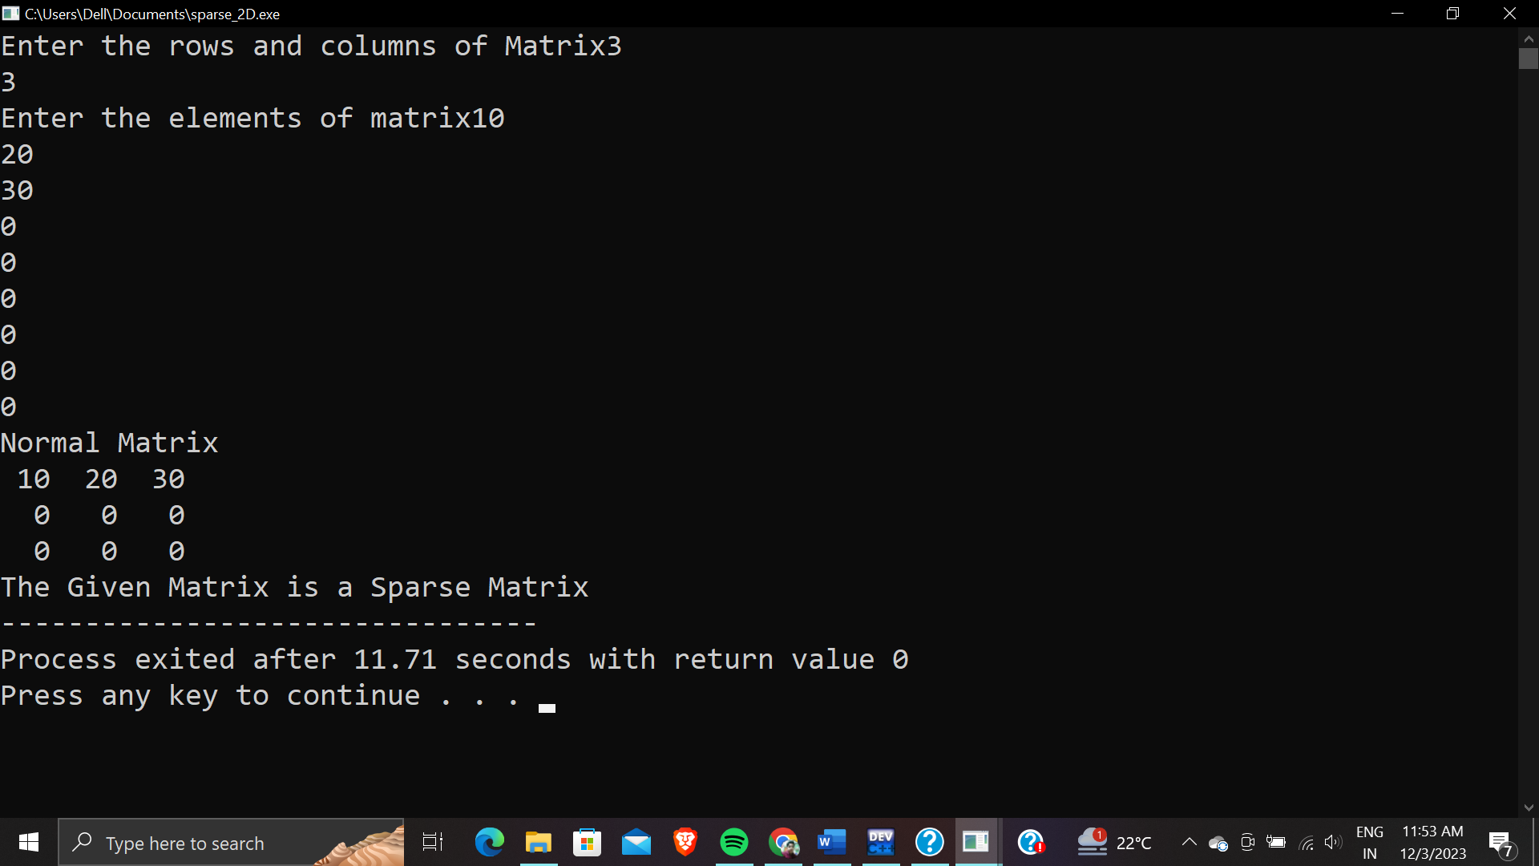

**Q.21 WAP to check whether the number is even or odd.(using goto() ).**

**Ans.**  #include<stdio.h>

#include<stdlib.h>

int main()

{

int n;

printf("please enter a no");

scanf("%d",&n);

if(n%2==0)

{

goto even;

}

else

{

goto odd;

}

even:

printf("%d is even",n);

exit(0);

odd:

printf("%d is odd",n);

return 0;

}

Output:-

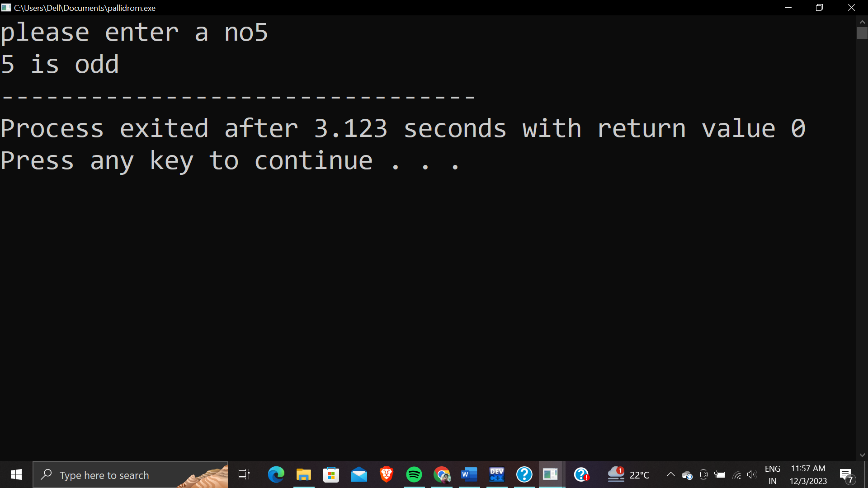

**Q.22 WAP to print a string of diamond taking the no. of diamonds in it from user.**

**Ans.**  #include<stdio.h>

#include<conio.h>

int main()

{

int i, j;

// Print the upper part of the heart

for (i = 1; i <= 3; i++) {

for (j = 1; j <= 3 - i; j++) {

printf(" ");

}

for (j = 1; j <= 2 * i - 1; j++) {

printf("*");

}

for (j = 1; j <= 3 - i; j++) {

printf(" ");

}

printf("\n");

}

// Print the lower part of the heart

for (i = 2; i >= 1; i--) {

for (j = 1; j <= 3 - i; j++) {

printf(" ");

}

for (j = 1; j <= 2 * i - 1; j++) {

printf("*");

}

for (j = 1; j <= 3 - i; j++) {

printf(" ");

}

printf("\n");

}

// Print the upper part of the heart

for (int i = 1; i <= 3; i++) {

for (int j = 1; j <= 3 - i; j++) {

printf(" ");

}

for (int j = 1; j <= 2 * i - 1; j++) {

printf("*");

}

for (int j = 1; j <= 3 - i; j++) {

printf(" ");

}

printf("\n");

}

// Print the lower part of the heart

for (int i = 2; i >= 1; i--) {

for (int j = 1; j <= 3 - i; j++) {

printf(" ");

}

for (int j = 1; j <= 2 * i - 1; j++) {

printf("*");

}

for (int j = 1; j <= 3 - i; j++) {

printf(" ");

}

printf("\n");

}

// Print the upper part of the heart

for (int i = 1; i <= 3; i++) {

for (int j = 1; j <= 3 - i; j++) {

printf(" ");

}

for (int j = 1; j <= 2 * i - 1; j++) {

printf("*");

}

for (int j = 1; j <= 3 - i; j++) {

printf(" ");

}

printf("\n");

}

// Print the lower part of the heart

for (int i = 2; i >= 1; i--) {

for (int j = 1; j <= 3 - i; j++) {

printf(" ");

}

for (int j = 1; j <= 2 * i - 1; j++) {

printf("*");

}

for (int j = 1; j <= 3 - i; j++) {

printf(" ");

}

printf("\n");

}

// Print the upper part of the heart

for (int i = 1; i <= 3; i++) {

for (int j = 1; j <= 3 - i; j++) {

printf(" ");

}

for (int j = 1; j <= 2 * i - 1; j++) {

printf("*");

}

for (int j = 1; j <= 3 - i; j++) {

printf(" ");

}

printf("\n");

}

// Print the lower part of the heart

for (int i = 2; i >= 1; i--) {

for (int j = 1; j <= 3 - i; j++) {

printf(" ");

}

for (int j = 1; j <= 2 * i - 1; j++) {

printf("*");

}

for (int j = 1; j <= 3 - i; j++) {

printf(" ");

}

printf("\n");

}

return 0;

}

Output:-

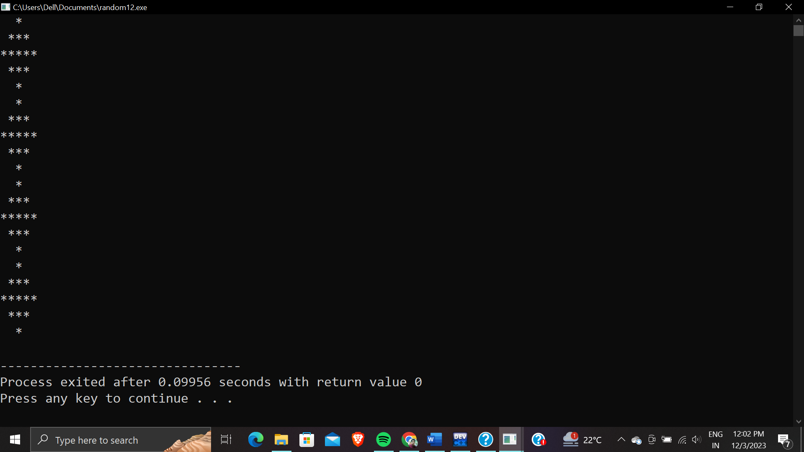

**Q.23 WAP to print a geometric progression.**

**Ans.**  #include<stdio.h>

#include<math.h>

int main()

{

int n,a,r,sum,gp;

printf("please enter the no. of terms of the GP");

scanf("%d",&n);

printf("please enter the first term of the GP");

scanf("%d",&a);

printf("please enter the common ratio of the GP");

scanf("%d",&r);

printf("Geometric Progression is : ");

for(int i=0;i<=(n-1);i++)

{

gp=a*pow(r,i);

printf("%d ,",gp);

}

printf("\b.");

if(r>1&&r!=1)

{

sum=a*(1-pow(r,n))/(1-r);

}

else if(r<1&&r!=1)

{

sum=a*(pow(r,n)-1)/(1-r);

}

else

{

sum=n*a;

}

printf("\nSum of GP is %d",sum);

return 0;

}

Output:-

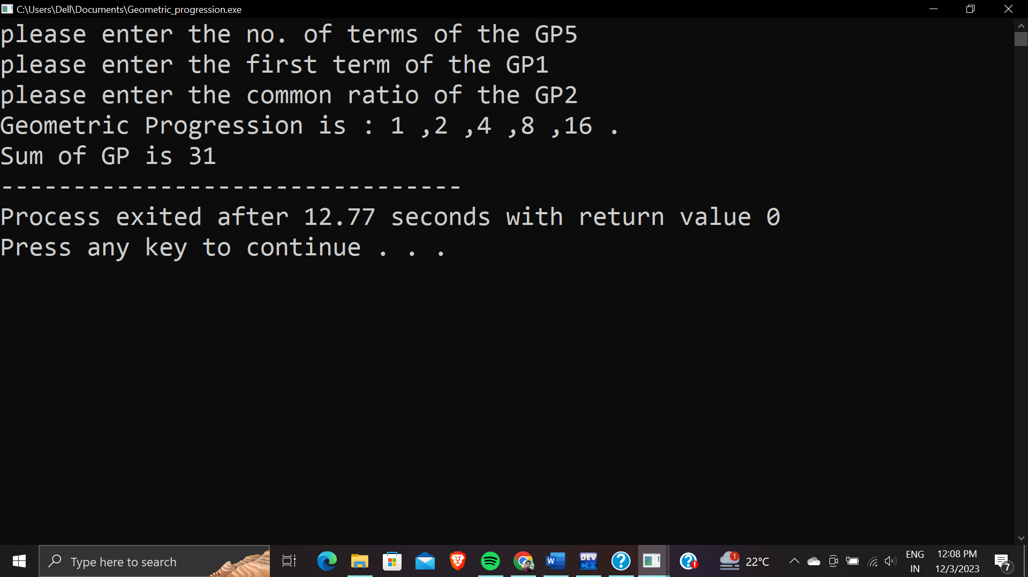

**Q.24 WAP to print the Fibonacci series upto a range.(taken by the user).**

**Ans.**  #include<stdio.h>

int main(){

int a=0,b=1,c;

int n;

scanf("%d",&n);

for(int i=1; i<=n; i++)

{

printf("%d\t",a);

c=a+b;

a=b;

b=c;

}

return 0;

}

Output:-

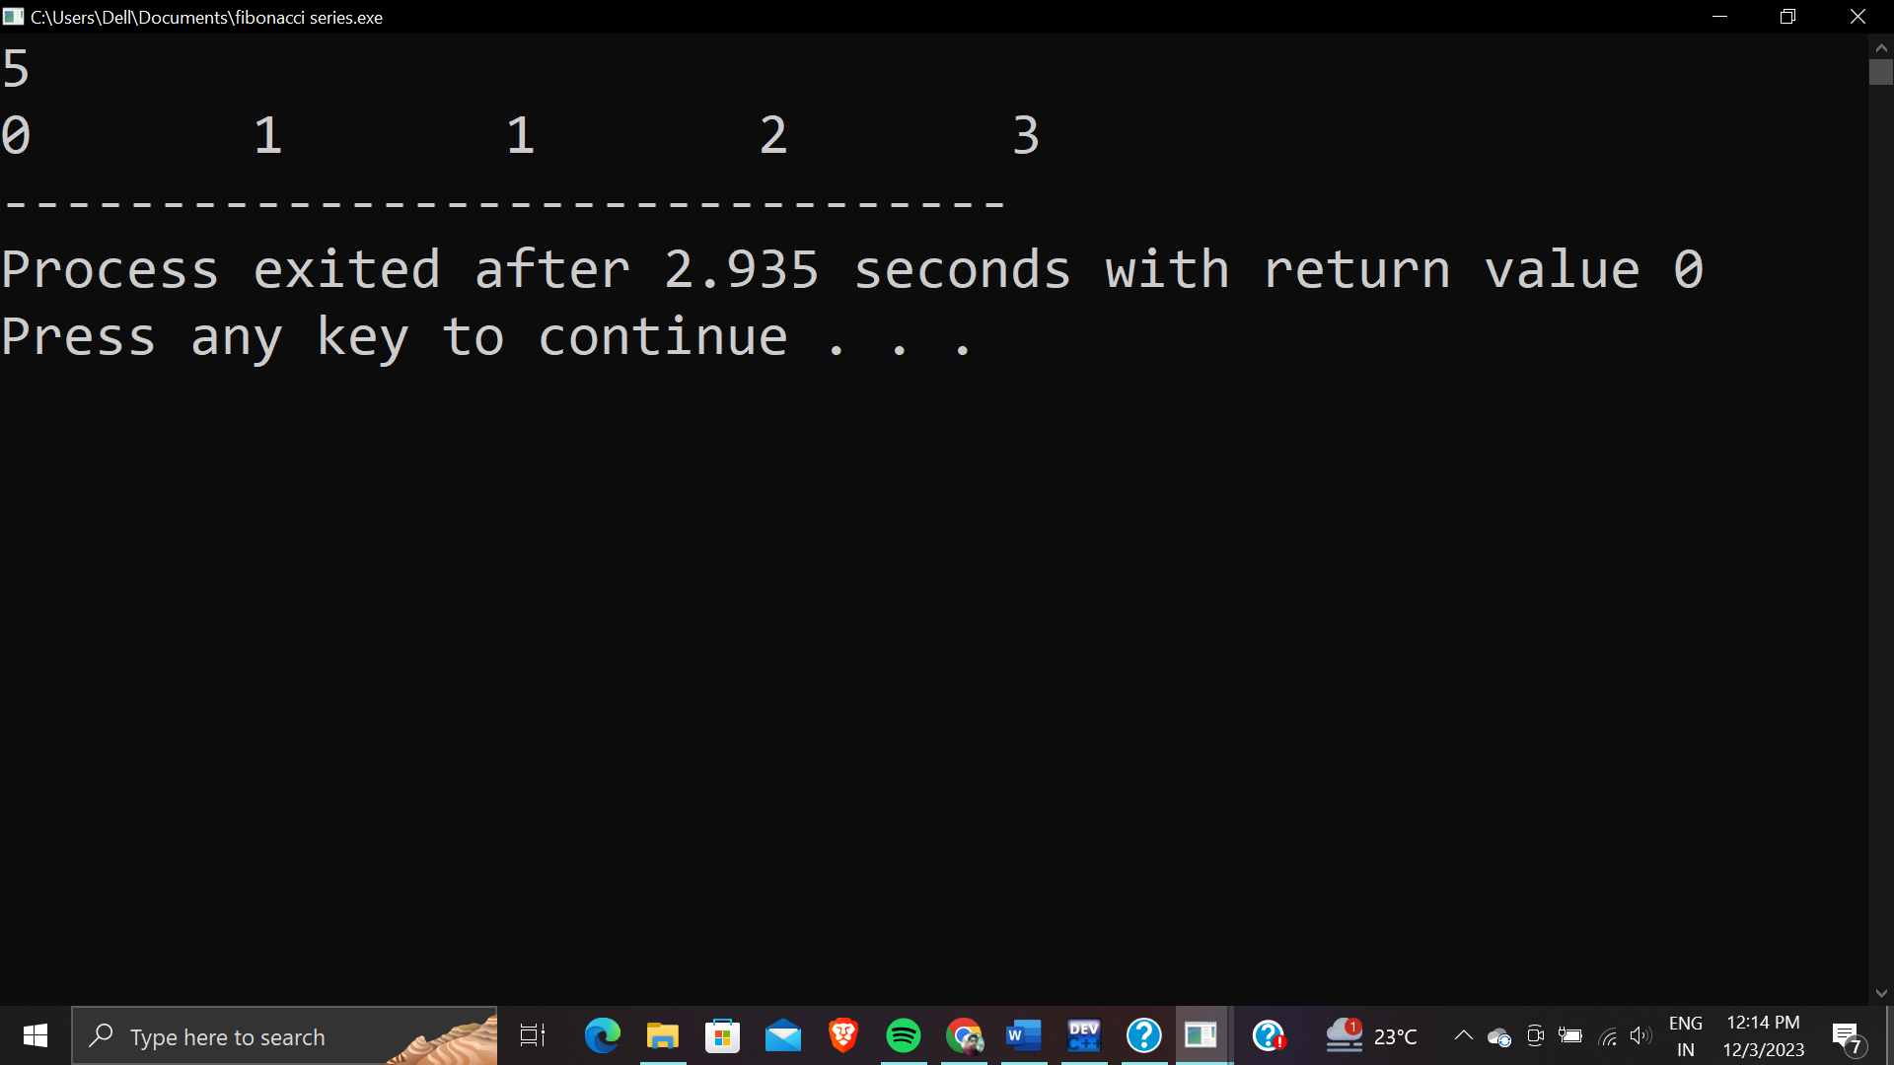

**Q.25 WAP to print the multiplication matrix of two matrices.**

**Ans.**  #include<stdio.h>

int main()

{

int m,n;

printf("Enter the rows and columns of 1st matrix");

scanf("%d%d",&m,&n);

int a[m][n];

printf("Enter the elements of matrices1");

for(int i=0;i<m;i++)

{

for(int j=0;j<n;j++)

{

scanf("%d",&a[i][j]);

}

}

int r,c;

printf("Enter the rows and columns of 2nd matrix");

scanf("%d%d",&r,&c);

int b[r][c];

printf("Enter the elements of matrices2");

for(int i=0;i<r;i++)

{

for(int j=0;j<c;j++)

{

scanf("%d",&b[i][j]);

}

}

int mul[m][n];

for(int i=0;i<m;i++)

{

for(int j=0;j<n;j++)

{

mul[i][j]=0;

for(int k=0;k<c;k++)

{

mul[i][j]+=a[i][k]*b[k][j];

}

}

}

for(int i=0;i<m;i++)

{

for(int j=0;j<n;j++)

{

printf("%d ",mul[i][j]);

}

printf("\n");

}

return 0;

}

OUTPUT:-

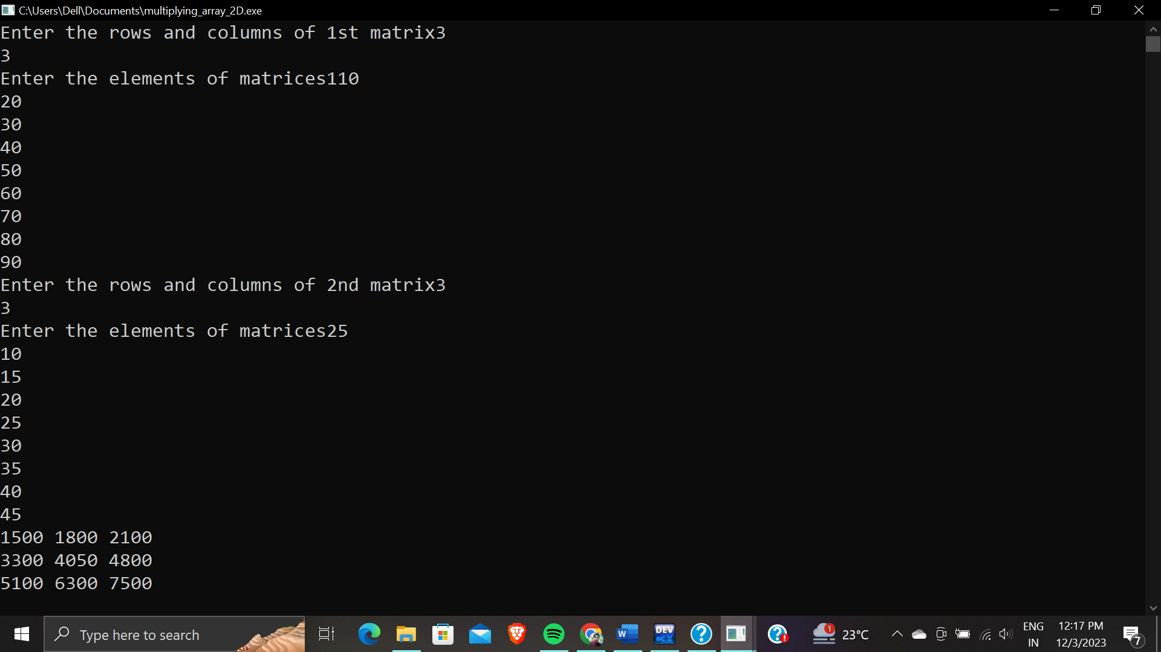

**\*-------------------THANK YOU-------------------\***